TrialWorks Version 11.2
Template Updates and Bookmarks
New Template and Bookmark features have been added to Version 11.2 to make document creation more effective. The newest Bookmarks are included for the generation of Settlement Statements and other Cost Detail information

What’s New

Bookmarks by Tab

Cost Tab
CostTotal -- pull Total Cost
CostTotalReduction -- pull Total Reduction
CostTotalAmountDue -- pull Total Amount Due

Medical Tab
By Client
MedsAmtWaived -- pull Amount Waived
MedsFinalBalanceDue -- pull Final Balance Due

By Other Party
OtherMedsOwed -- pull Total Bill
OtherMedsPaid -- pull Amount Paid
OtherMedsTotal -- pull Balance
OtherMedsAmtWaived -- pull Amount Waived
OtherMedsFinalBalanceDue -- pull Final Balance Due

By Case
CaseMedsOwed -- pull Total Bill
CaseMedsPaid -- pull Amount Paid
CaseMedsTotal -- pull Balance
CaseMedsAmtWaived -- pull Amount Waived
CaseMedsFinalBalanceDue -- pull Final Balance Due

Insurance/Liens Tab
TotalPolicyLimit -- pull Total Policy Limit
LiensTotalAmount -- pull Total Amount of Lien
LiensTotalReduction -- pull Total Reduction
LiensTotalAmountDue -- pull Total Amount Due

Settlement Info (Case Settlement)
SettInfoExpectedSettlementDate -- pull Expected Settlement Date
SettInfoSettlementDate -- pull Settlement Date
SettInfoSettlementAmount -- pull Settlement Amount
SettInfoTotalAllClients -- pull Total Settlement (All Clients)

Bookmarks by Client

Costs Tab -- cost amount should pull from cost tab amount due field by party
By Client
ClientCostDetail_Total -- itemize each cost separately sorted by date oldest to newest
07/15/2018 | Kennedy Consulting | $5,000.00
07/22/18 | MRO | $30.00
07/29/2018 | MRO | $5.00
08/01/2018 | Seaview Ortho | $665.00
Total Costs: |  | $5,700.00

ClientCostDetail -- itemize each cost separately sorted by date oldest to newest
07/15/2018 | Kennedy Consulting | $5,000.00
07/22/18 | MRO | $30.00
07/29/2018 | MRO | $5.00
08/01/2018 | Seaview Ortho | $665.00
ClientCostDetailGB_Total -- group by payee
Kennedy Consulting | $5,000.00
MRO | $35.00
Seaview Ortho | $665.00
Total Costs: | $5,700.00

ClientCostDetailGB -- group by payee
Kennedy Consulting | $5,000.00
MRO | $35.00
Seaview Ortho | $665.00

Medical Tab -- medical amount should pull from the medical tab final balance due field by client
By Client
ClientMedicalDetail_Total -- itemize each medical provider separately sorted by date oldest to newest
06/12/2018 | Mount Sinai |  | $3,500.00
07/25/18 | Abe Sinister, MD |  | $250.00
08/03/2018 | Abe Sinister, MD |  | $125.00
Total Outstanding Medical bills |  |  | $3,875.00

ClientMedicalDetail -- itemize each medical provider separately sorted by date oldest to newest
06/12/2018 | Mount Sinai | $3,500.00
07/25/18 | Abe Sinister, MD | $250.00
08/03/2018 | Abe Sinister, MD | $125.00

ClientMedicalDetailGB_Total -- group by provider
Mount Sinai | $3,500.00
Abe Sinister, MD | $375.00
Total Outstanding Medical bills | $3,875.00

ClientMedicalDetailGB -- group by provider
Mount Sinai | $3,500.00
Abe Sinister, MD | $375.00

Medical Tab -- medical amount should pull from the medical tab final balance due field by other party
By Other Party
OtherMedicalDetail_Total -- itemize each medical provider separately sorted by date oldest to newest
06/12/2018 | Mount Sinai |  | $3,500.00
07/25/18 | Abe Sinister, MD |  | $250.00
08/03/2018 | Abe Sinister, MD |  | $125.00
Total Outstanding Medical bills |  |  | $3,875.00

OtherMedicalDetail -- itemize each medical provider separately sorted by date oldest to newest
06/12/2018 | Mount Sinai | $3,500.00
07/25/18 | Abe Sinister, MD | $250.00
08/03/2018 | Abe Sinister, MD | $125.00

OtherMedicalDetailGB_Total -- group by provider
Mount Sinai | $3,500.00
Abe Sinister, MD | $375.00
Total Outstanding Medical bills | $3,875.00

OtherMedicalDetailGB -- group by provider
Mount Sinai | $3,500.00
Abe Sinister, MD | $375.00

Insurance/Liens Tab -- lien amount should pull from lien tab amount due field by party
By Client
ClientLienDetail_Total -- itemize each lienholder separately sorted by date oldest to newest
06/12/2018 | Mount Sinai |  | $3,500.00
07/25/18 | Abe Sinister, MD |  | $250.00
08/03/2018 | Abe Sinister, MD |  | $125.00
Total Liens |  |  | $3,875.00

ClientLienDetail -- itemize each lienholder separately sorted by date oldest to newest
06/12/2018 | Mount Sinai | $3,500.00
07/25/18 | Abe Sinister, MD | $250.00
08/03/2018 | Abe Sinister, MD | $125.00

ClientLienDetailGB_Total -- group by lien holder
Mount Sinai | $3,500.00
Abe Sinister, MD | $375.00
Total Liens | $3,875.00

ClientLienDetailGB -- group by lienholder
Mount Sinai | $3,500.00
Abe Sinister, MD | $375.00

Bookmarks by Case

Costs Tab -- cost amount should pull from cost tab amount due field
CaseCostDetail_Total -- itemize each cost entry separately sorted by date oldest to newest
07/15/2018 | Kennedy Consulting | $5,000.00
07/22/18 | MRO | $30.00
07/29/2018 | MRO | $5.00
08/01/2018 | Seaview Ortho | $665.00
Total Costs: |  | $5,700.00

CaseCostDetail -- itemize each cost entry separately by date oldest to newest
07/15/2018 | Kennedy Consulting | $5,000.00
07/22/18 | MRO | $30.00
07/29/2018 | MRO | $5.00
08/01/2018 | Seaview Ortho | $665.00

CaseCostDetailGB_Total -- group by payee
Kennedy Consulting | $5,000.00
MRO | $35.00
Seaview Ortho | $665.00
Total Costs: | $5,700.00

CaseCostDetailGB -- group by payee
Kennedy Consulting | $5,000.00
MRO | $35.00
Seaview Ortho | $665.00

Medical Tab -- medical amount should pull from medical tab final balance due field

CaseMedicalDetail_Total -- itemize each medical provider separately sorted by date oldest to newest
06/12/2018 | Mount Sinai |  | $3,500.00
07/25/18 | Abe Sinister, MD |  | $250.00
08/03/2018 | Abe Sinister, MD |  | $125.00
Total Outstanding Medical bills |  |  | $3,875.00

CaseMedicalDetail -- itemize each medical provider separately sorted by date oldest to newest
06/12/2018 | Mount Sinai | $3,500.00
07/25/18 | Abe Sinister, MD | $250.00
08/03/2018 | Abe Sinister, MD | $125.00
CaseMedicalDetailGB_Total -- group by provider
Mount Sinai | $3,500.00
Abe Sinister, MD | $375.00
Total Outstanding Medical bills | $3,875.00

CaseMedicalDetailGB -- group by provider
Mount Sinai | $3,500.00
Abe Sinister, MD | $375.00

Insurance/Liens Tab -- lien amount should pull from lien tab amount due field
CaseLienDetail_Total -- itemize each lienholder separately sorted by date oldest to newest
06/12/2018 | Mount Sinai |  | $3,500.00
07/25/18 | Abe Sinister, MD |  | $250.00
08/03/2018 | Abe Sinister, MD |  | $125.00
Total Liens |  |  | $3,875.00

CaseLienDetail -- itemize each lienholder separately sorted by date oldest to newest
06/12/2018 | Mount Sinai | $3,500.00
07/25/18 | Abe Sinister, MD | $250.00
08/03/2018 | Abe Sinister, MD | $125.00

CaseLienDetailGB_Total -- group by lien holder
Mount Sinai | $3,500.00
Abe Sinister, MD | $375.00
Total Liens | $3,875.00

CaseLienDetailGB -- group by lien holder
Mount Sinai | $3,500.00
Abe Sinister, MD | $375.00

Template Wizard
TrialWorks Version 11.2 now includes an intensive change in how users create templates. A state-of-the-art Office Addin provides a link directly to the TrialWorks database to add bookmarks directly to any document. Choose the tab to generate a template and a searchable list of fields appear. Don’t want to create a template? You can add the field data directly to your document with an alternative search.

TrialWorks Toolbar
The Template Wizard has been added to the TrialWorks Office Addin Toolbar
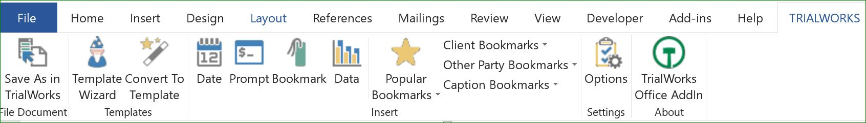
Choosing the Template Wizard, you are prompted to pick the type of template you need to create
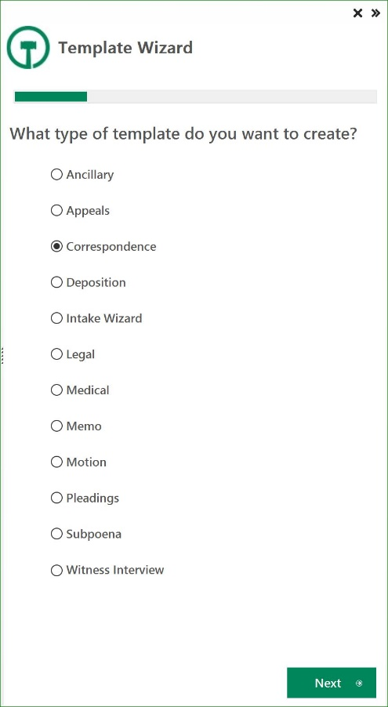
A list of bookmarks appears – you can search by bookmark name, field name or tab
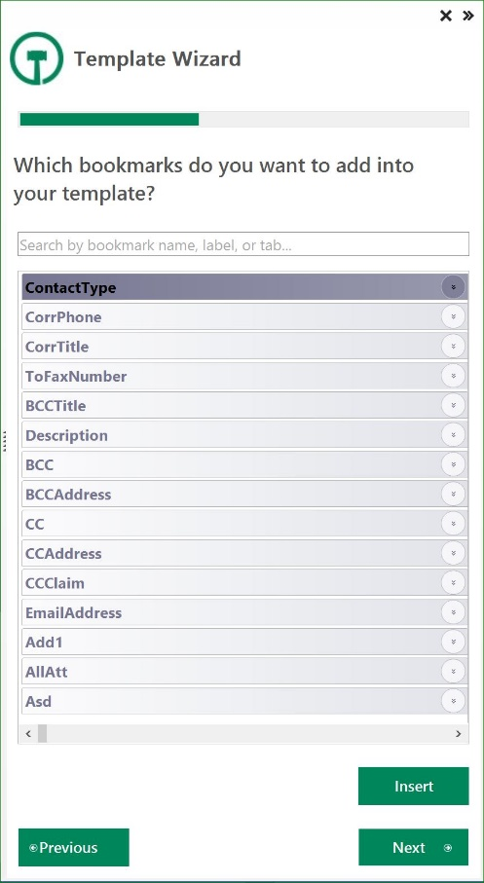
Choose a Case, Client, Other Party, Caption and Insurance to Test your Template
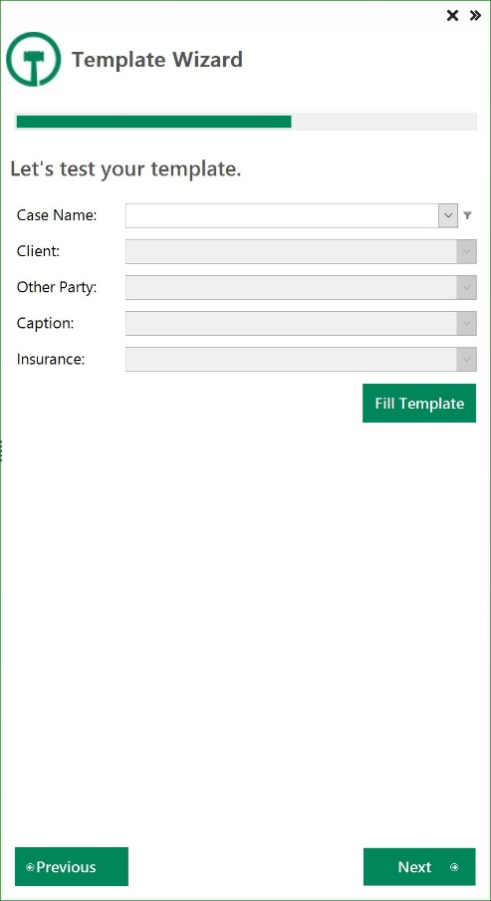
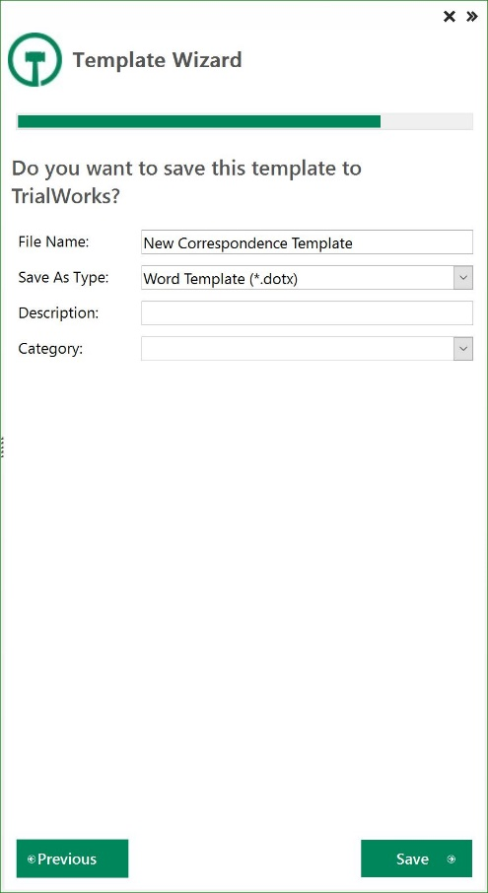
Choose to Test your template by choosing a Case. This allows you to modify the Bookmarks before saving your template.

Save your template with a new File Name, document type, a description that shows when the user looks at the list of templates and the Template Category

How to Insert Bookmarks
Bookmarks can be searched for or located in the list. You can click the information icon on the right of a field to discover where the bookmark originates and what data will complete when inserted. An example of the CorrPhone bookmark is shown below:
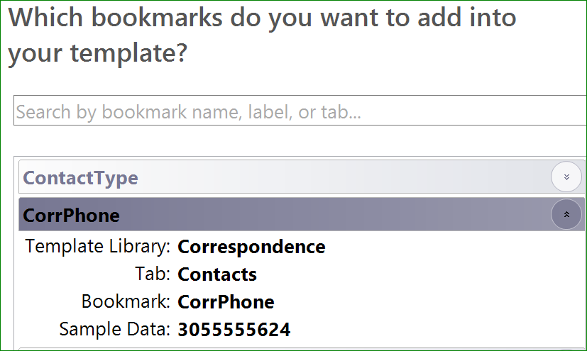
Place your cursor in the document where you want to add the Bookmark and once you’ve located the Bookmark in the list, double-click on the Bookmark name to add it to your document.

Use Quick Access
Quick Access has been provided to common bookmarks to make template creation easier
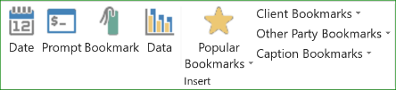
Choose to add the Date or one of the other Popular, Client, Other Party or Caption Bookmarks

Add a Prompt
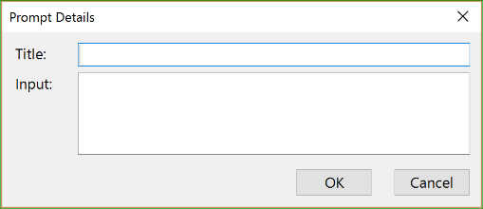
If the data you need to pull into your template doesn’t exist in TrialWorks, you can choose to add a prompt. This allows your user to complete the section with optional text needed.

How to Insert Data
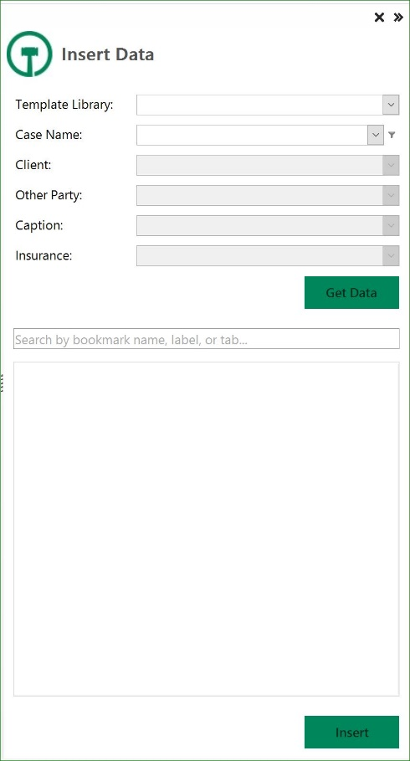
If you need to add additional data to a document, you can choose the option from the TrialWorks Office Addin to Insert Data.
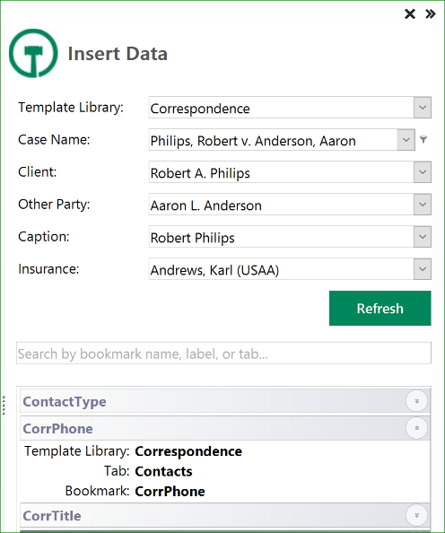
Populating the options in the fields sets the criteria for the case data to be inserted into your document.
Note: the case name field is filtered for All Active Cases by default.

Save your Document as a Template
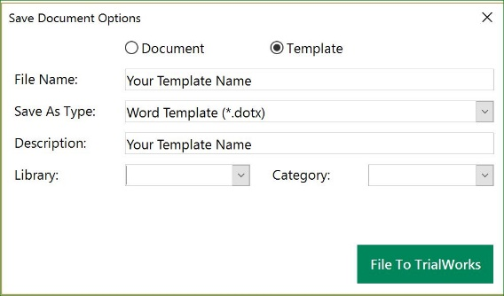
If you’ve created a new document and now want to save it as a Template complete the fields for File Name, Save as Type, Description (what you’ll see when you pick the template), Library and Template.

