Using FileIT With TrialWorks
  - Version 11 and higher
The FileIT program allows you to import documents directly into an individual tab in TrialWorks cases. Files previously saved to local hard drives or network folders move to the TrialWorks Casefiles folder.
- Open FileIT from the Desktop icon
- The FileIT window appears

Open Folder | 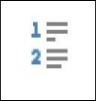  Import Files | Clear Import List | Assign to All | Delete Transfer List | Transfer Files | Close FileIT
- Open Folder – Use to add a folder to Import From each time you open FileIT
- Import Files – Use to add all files in the Import From folder into FileIT
- Clear Import – Use to clear the previous folders available in the Import From drop-down list
- Assign to All – Use to Assign a Case, Tab, Document Category, Author, Party, Date and Received to All documents listed on the Transfer List
- Delete Transfer List – Use to clear the list of files
- Transfer Files – Use to transfer all files tagged with a Case and Document Tab to TrialWorks
- Close FileIT – Use to Close the FileIT Program

Transferring Documents
- Click on the Open Folder icon to the upper right of the FileIT window to choose the directory that you want to import files. Scroll through the Browse for Folder window, choose the directory where you have saved the files (or scanned images) you want to import into TrialWorks. Choosing an Import From folder saves the folder as a default to transfer files. No files show in this view.
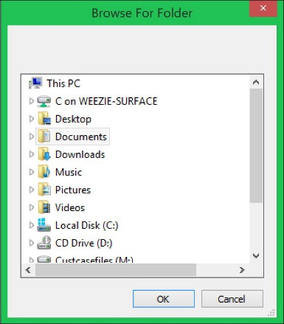
- Click the Import Files icon. The files that you want to import into TrialWorks are listed on the transfer list.
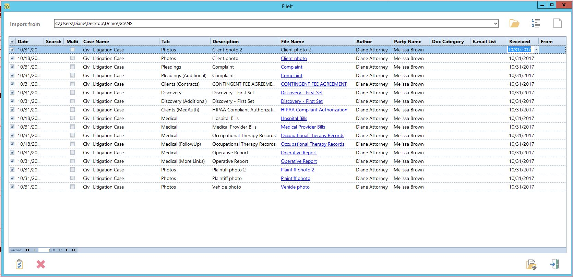
- If you need to change the date, click on the Date field and click the drop-down arrow to choose the date from a calendar or start typing the date of the document. If you are filing multiple documents with the same date, you can click the Assign to All button at the bottom of the FileIT window to choose the date.
- Click in the Search field to search for your case by file number.
- Check the box for Multi to add a single document to multiple cases.
- Click on the Case Name field and click the drop-down arrow or start typing the name of the case you want the files to transfer. If you are filing multiple documents into the same case, you can click the Assign to All button at the bottom of the FileIT window to choose the case. You can also filter the list of cases by clicking on the Filter icon and Refresh the case list for any new cases added to TrialWorks while FileIT was opened.
- Click on the Tab field and click the drop-down arrow or start typing the tab name to choose the correct tab that the file to transfer. If you are filing multiple documents into the same tab, you can click the Assign to All button at the bottom of the FileIT window to choose the tab.
- Click on the Author field and either click the drop-down arrow or start typing the name of the individual who signed the document. If you are filing multiple documents signed by the same author, you can click the Assign to All button at the bottom of the FileIT window to choose the author.
- Click on the Party Name field and click the drop-down arrow or start typing the name of the Party to associate the document. If you are filing multiple documents signed by the same Party Name, you can click the Assign to All button at the bottom of the FileIT window to choose the author.
- Click in the Doc Category field and click the drop-down arrow or start typing the document category the file should be assigned. If you are filing multiple documents into the same tab, you can click the Assign to All button at the bottom of the FileIT window to choose the tab.
- Email List - With the “Send E-mail from FileIT” option enabled in the Global Settings of TrialWorks, FileIT creates an e-mail with a shortcut to the document for each record that you transfer. The e-mail fills in the default invitees that were selected on the Case Info tab of the case. If this default setting is turned on, the default invitee names appear in the To field when the E-mail is created. You can also add any additional names in the Email List field
- Click on the Date Received field and click the drop-down arrow to choose the date from a calendar or type the date the document was received. If you are filing multiple documents with the same received date, you can click the Assign to All button at the bottom of the FileIT window to choose the date.
- Click on the “Transfer Files” button to transfer all files assigned to cases. The individual files move from their original storage location to the appropriate Casefiles storage location by case. Only the files that you have assigned both a CASE and a TAB are transferred. Don’t worry if you have other files listed here that you are not ready to transfer.
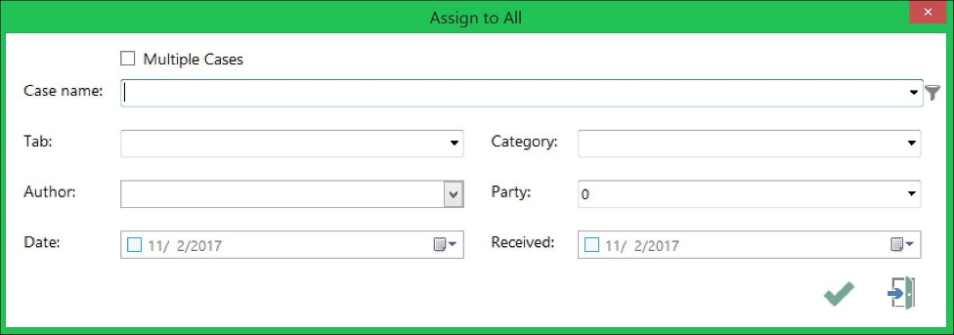
- Click the checkbox to choose Multiple Cases to assign the documents in the Transfer List to multiple cases.
- Use the Filter (funnel) icon to limit the list of cases shown in the Case Name drop-down and Refresh the case list for any new cases added to TrialWorks while FileIT was opened.
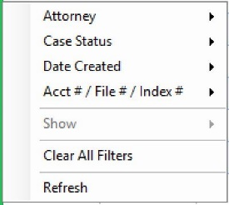

Transferring Additional Documents
Often you need to associate a signed, or court stamped document into the Additional or More Links field of a document created in TrialWorks. You can file documents to the following:
- Ancillary (Additional), Ancillary (More Links)
- Appeals (Additional)
- Clients (Contracts) Clients (MedAuth)
  - Files transferred are placed into a “Temp” folder in the Casefiles folder for that case
- Correspondence (Additional), Correspondence (More Links)
- Costs
- Deposition (Additional), Deposition (More Links), Deposition (Summary), Deposition (Transcript)
- Discovery (Additional), Discovery (More Links)
- Experts (Witness Interview), Experts(Additional), Experts (Investigatory), Experts (Memo), Experts (More Links)
- Insurance
  - Files transferred are placed into a “Temp” folder in the Casefiles folder for that case
- Liens
  - Files transferred are placed into a “Temp” folder in the Casefiles folder for that case
- Medical [Records], Medical (FollowUp), Medical (More Links), Medical (Request)
- Memo Additional, Memo (More Links)
- Motions (Additional), Motions (More Links), Motions (Transcripts)
- Negotiations
  - Files transferred are placed into a “Temp” folder in the Casefiles folder for that case
- Pleadings (Additional), Pleadings (More Links)
- Subpoena (Additional), Supoena (More Links)
Tagging a file to the Additional, More Links or one of the custom tab document links prompts you to locate your original link. Line up your document with a current entry
- Choose the tab and the additional or custom option in the drop-down and identify the existing entry to link the document.
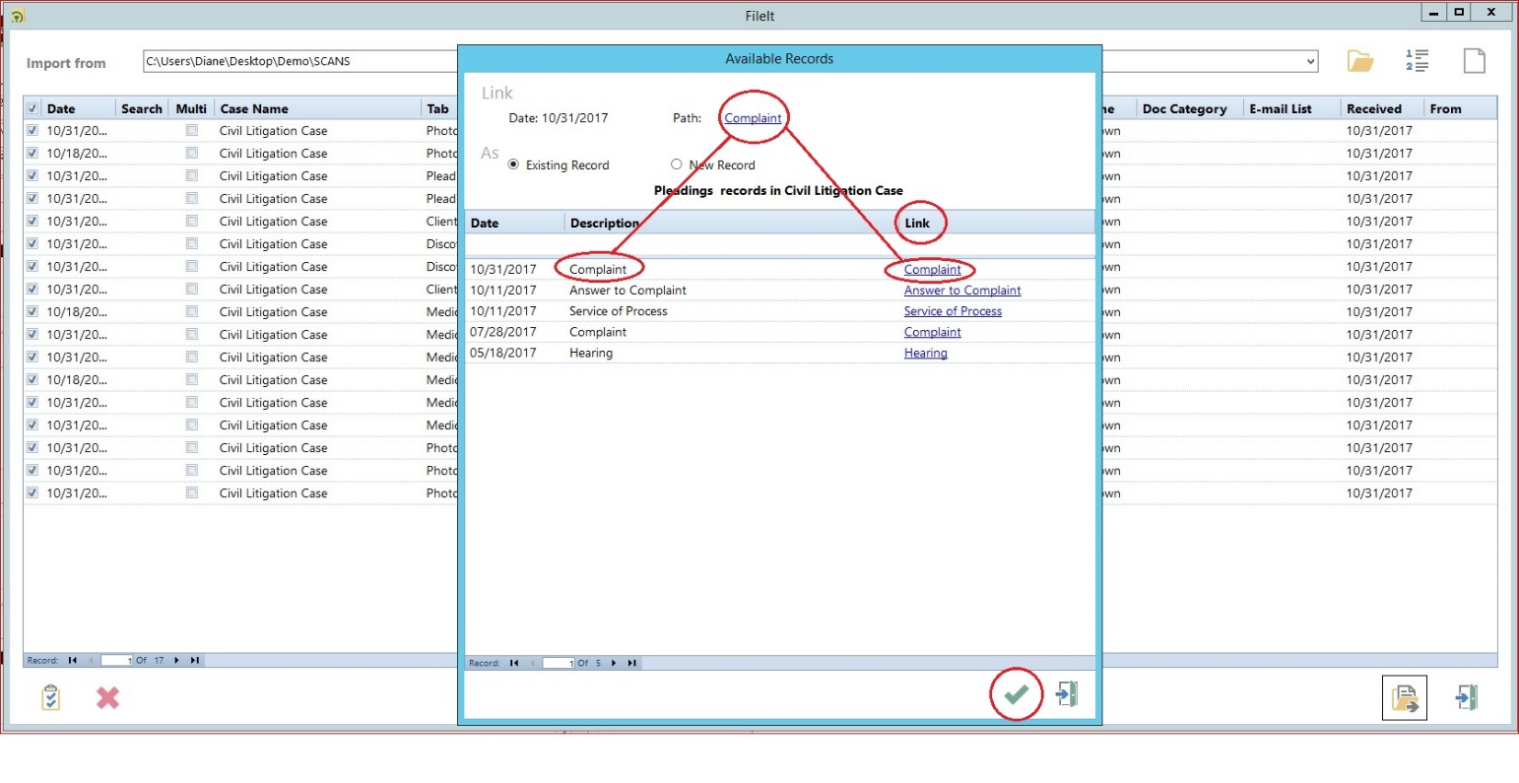

Drag and Drop Files to FileIT
FileIT features the ability to drag a file to the FileIT icon and automatically launch the FileIT program.
- Open the folder containing the scanned image file.
- Click the file or the entire folder and drag it on top of the FileIT icon located on your desktop.
- FileIT opens and the file(s) is(are) added to the transfer list.
- Complete the required information as described above to transfer your documents.
- You also can drag and drop files (or folders) onto the FileIt grid if you already have FileIt open.
- It is recommended to Clear the Transfer List once you have completed your transfer process. This option does not delete the actual files that remain in the folder, just removes them from the FileIT window.

