LEVEL 1 USER TRAINING

HOUR 7 (ONLINE)

GETTING STARTED WITH TRIALWORKS

Docketing
Timetable of Scheduled Events and Tasks related to a specific case; enter data directly into this tab and send it to your Calendar. Reports detailing completed and pending activity

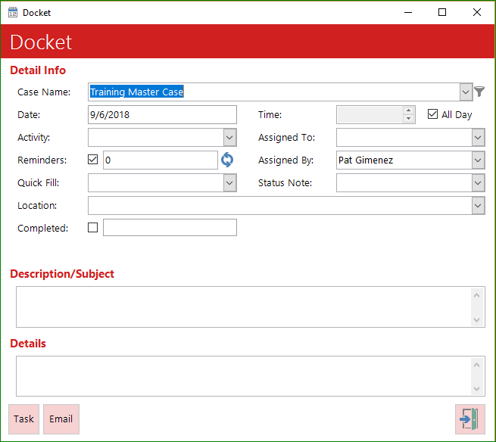
Basics
- How to enter a docket tickler and push to Outlook
- Setting reminders and recurring reminders
- Using Assigned To (Required/Not Required)
- Marking items dismissed or completed
- Marking Adjourned
- Reminders, Global Docket and TrialWorks Today

Outlook Bi-Directional Sync
- Calendar from Outlook and push to Docket Tab
  - Enter description, add recipients, date/time and additional details then click File to TrialWorks

Automated Docketing
- Templates
- Document Detail Windows

Fast Track
- Name the Fast Track
- Description (what you want to show as the description in the Docket Detail window)
- Days (how many days from the initiation date should the entry be added to the Docket)
- Business Days (calculate only M-F excluding Holidays)
- Time (if there should be a time associated with the docket entry)
- Reminder (if you want the item to show up on your Reminder List)
- DaysAdvance (if you want the Reminder to show up a certain number of days in advance of the due date)
- Calendar (to add the item to the Outlook Calendar)
- Task (to add the item to the Outlook Task)
- Link (if the item should be dependent on the completion of a previous item)
- Assigned To (if the item should be assigned to a particular individual for the responsibility of completing the entry)
- Activity (a term from the Docket Category/Activity Library to help sort entries on the Docket Tab)
- Deferred (if the item falls on a Saturday or Sunday whether to move the date to Friday, Monday or Don’t Change)
- Status Note Code (when does it get added)

Applying a Fast Track
- Date to apply from
- Add Fast Track
- Add Calendar
- Add Task
- Automatically Send
- Editing before adding

Re-Applying a Fast Track
- Unapplied Items

Automating Fast Track
- Linked to Liability

