LEVEL 1 USER TRAINING

HOUR 6 (ONLINE)

GETTING STARTED WITH TRIALWORKS
  - LITIGATION TABS

Pleading Tab, Discovery Tab and Appeals Tab
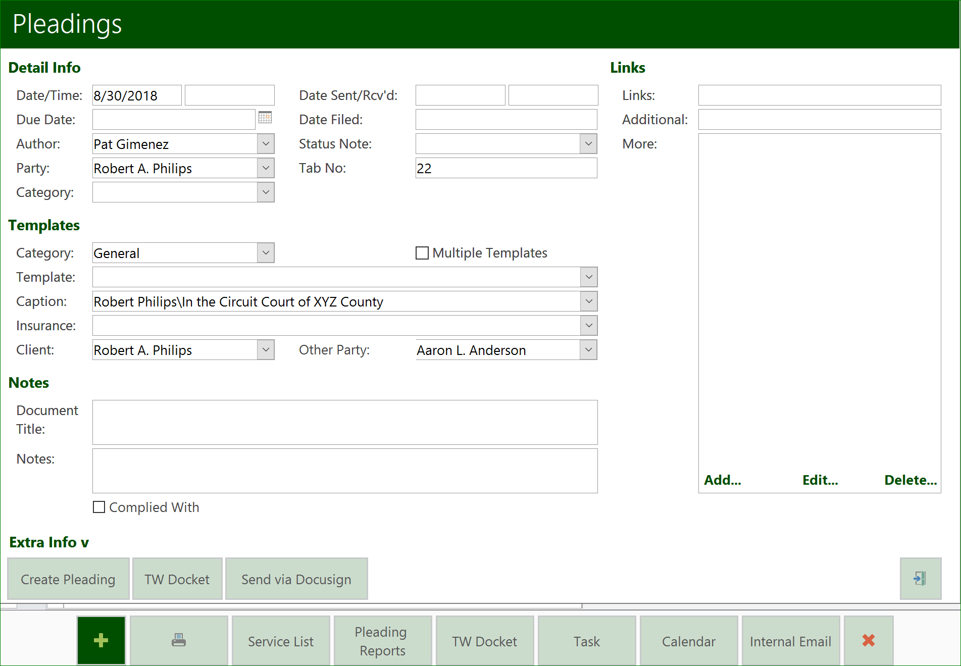
- Defaults in the detail windows  - Date (defaults to today)  - Author (pulls from User Defaults)  - Party (always the first client party name)  - Caption  - Client  - Other Party | - Options  - Template Category  - Template  - Insurance  - Subject  - Document Category
- Links
  - Link
  - Additional
  - More
- Date Filed
- Tab No
- Complied With

- Print
  - Prints Envelopes for all Attorneys on the Service List
- Service List
  - To link the Template you will use, go to User Tools, Default Values

- Pleadings Report
  - Date
  - Party
  - TabNo
  - Not Compiled
  - Category

Deposition Tab
Use this tab to create deposition notices, service lists, and store deposition transcripts. deposition preparations and summaries can also be created and linked to the original notice.
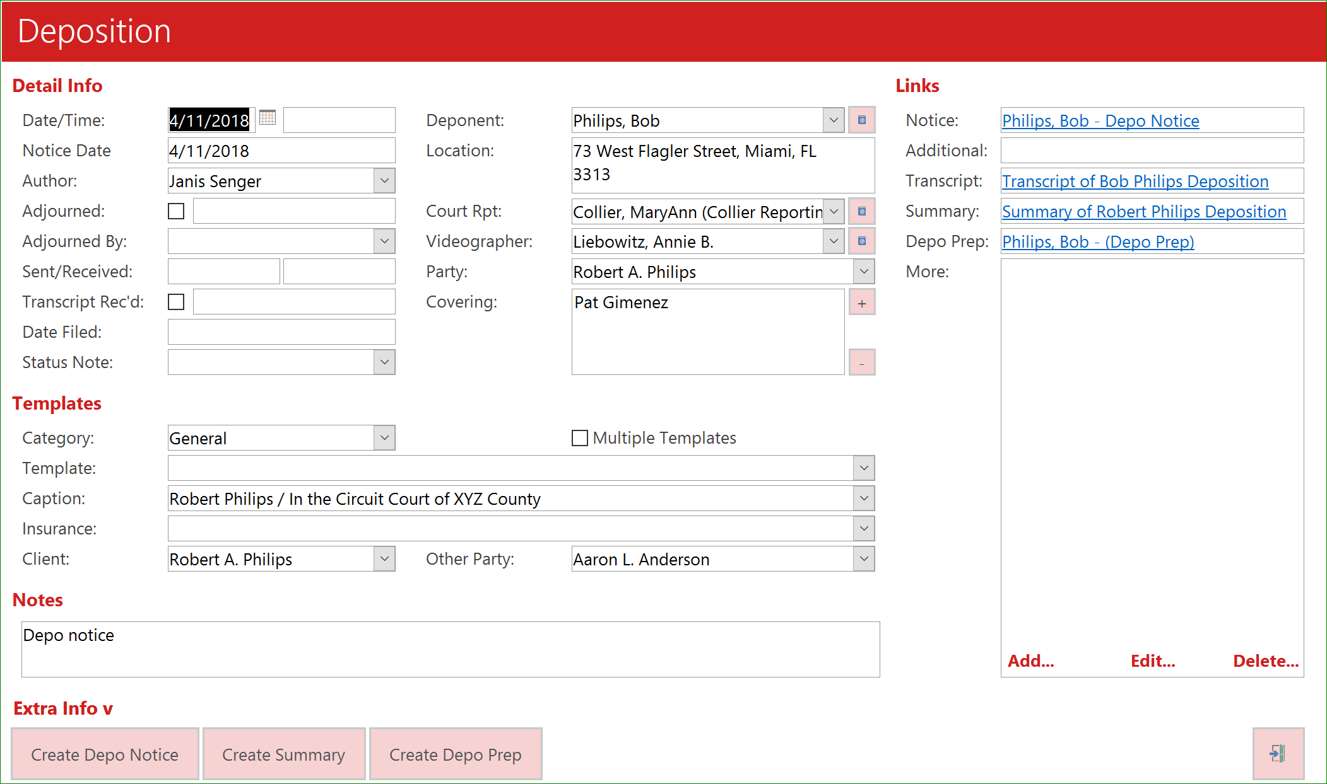
- Defaults in the detail windows  - Date (defaults to today)  - Author (pulls from User Defaults)  - Party (always the first client party name)  - Caption  - Client  - Other Party | - Options  - Template Category  - Template  - Insurance  - Subject  - Document Category
- Links
  - Notice
  - Additional
  - Transcript
  - Summary
  - Depo Prep
- Date
  - The Date of the Deposition
- Time
  - The time of the Deposition
- Notice Date
  - The date the Notice was prepared
- Adjourned
  - If checked, indicates that the deposition has been canceled.
  - When you select adjourned, you will get a prompt asking, “Do you want TrialWorks to automatically create a new Deposition Date with the Adjourned Date?”
- Adjourned by
  - The name of the individual who canceled the deposition
- Sent/Received
  - When was the Notice sent/received
- Transcript Rec’d
  - When was the transcript received
- Date Filed
- Status Note
- Deponent
- Location
- Court Rpt
- Videographer
- Party
- Covering

Subpoena Tab
Subpoenas require an individual or corporation to appear either at Trial or for a Non-Party deposition
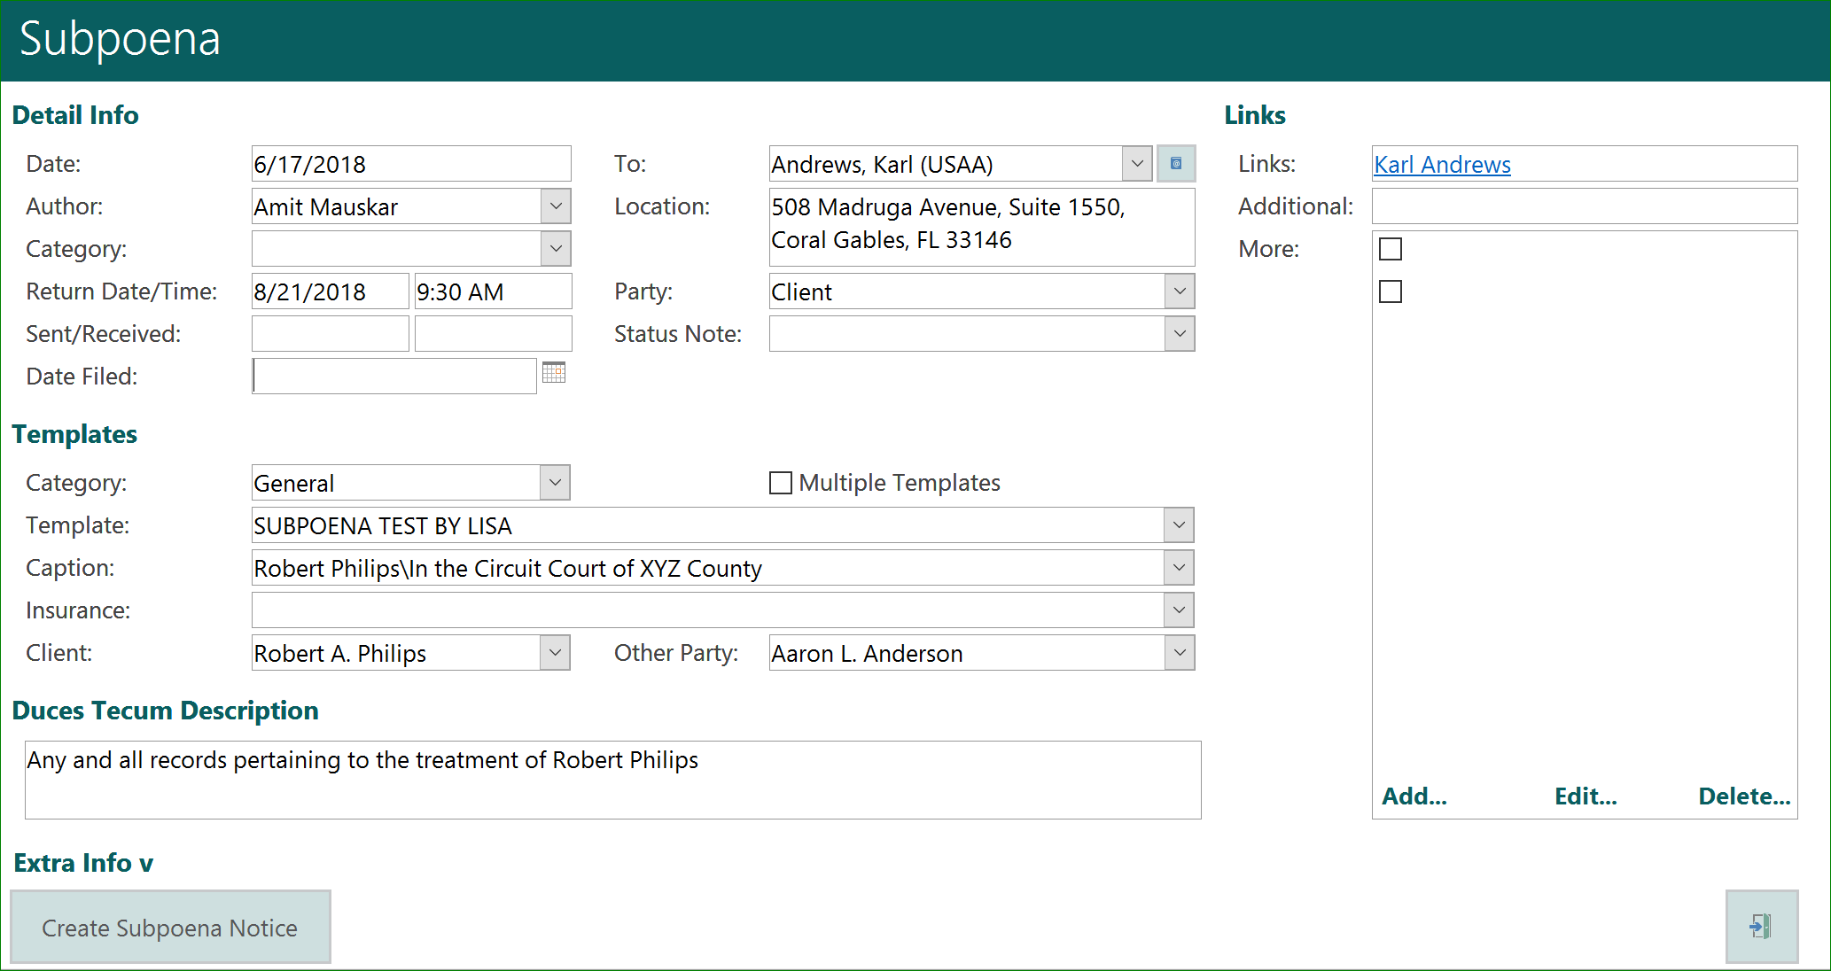
- Defaults in the detail windows  - Date (defaults to today)  - Author (pulls from User Defaults)  - Party (always the first client party name)  - Caption  - Client  - Other Party | - Options  - Template Category  - Template  - Insurance  - Subject  - Document Category
- Links
  - Notice
  - Additional
  - More
- Return Date
- Time
- Date Filed
- To
- Location

Hearings/Motions/Appearances
Use this tab to create hearing notices, as well as track hearing dates and cancellations and store actual hearing transcripts. It contains a log of hearings. Users can automatically send information to the TrialWorks Docket, and to your Calendar
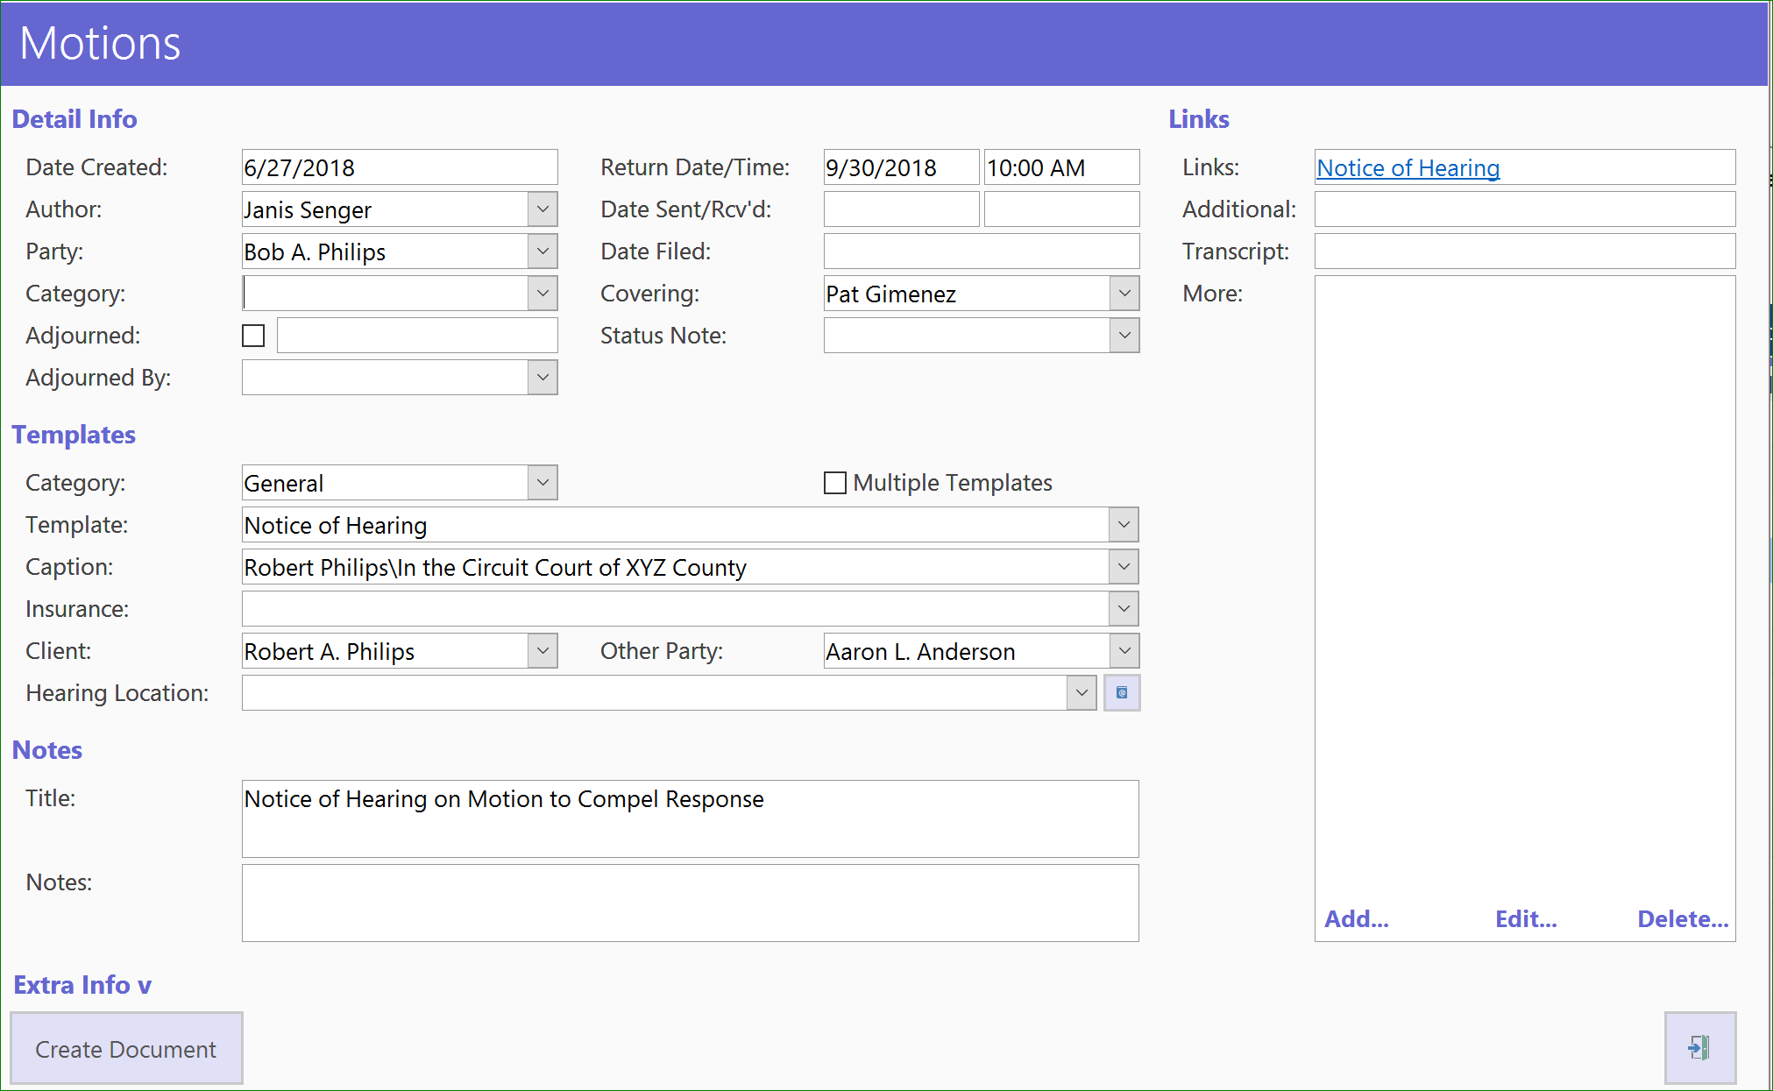
- Defaults in the detail windows  - Date (defaults to today)  - Author (pulls from User Defaults)  - Party (always the first client party name)  - Caption  - Client  - Other Party | - Options  - Template Category  - Template  - Insurance  - Subject  - Document Category
- Links
  - Notice
  - Additional
  - More
Additional Unique Fields
- Return Date/Time
- Date Filed
- Covering
- Hearing Location
- Title

Investigation
The Investigation Tab was original designed to house the initial accident investigation in an Auto case. It contains details of Witnesses and Police Info. Documents can not be created but are linked.
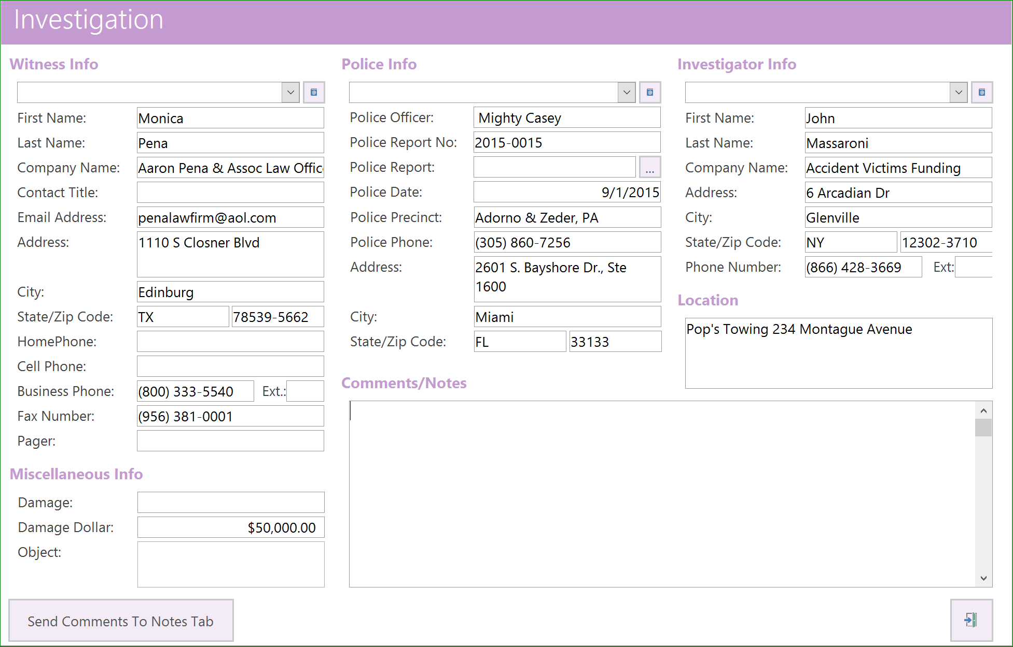
- Witness Info
- Miscellaneous Info
  - Damage
  - Damage Dollar
- Police Info
Police Report No. – Enter Information
Police Report – attached by using ellipsis
Police Date – enter Information
Comments/Notes regarding the Incident
- Investigator Info
- Location

