LEVEL 1 USER TRAINING

HOUR 5 (ONLINE)

GETTING STARTED WITH TRIALWORKS

Ancillary/Miscellaneous/Subrogation
A lawsuit that involved the death of someone could have an estate proceeding as an ancillary case
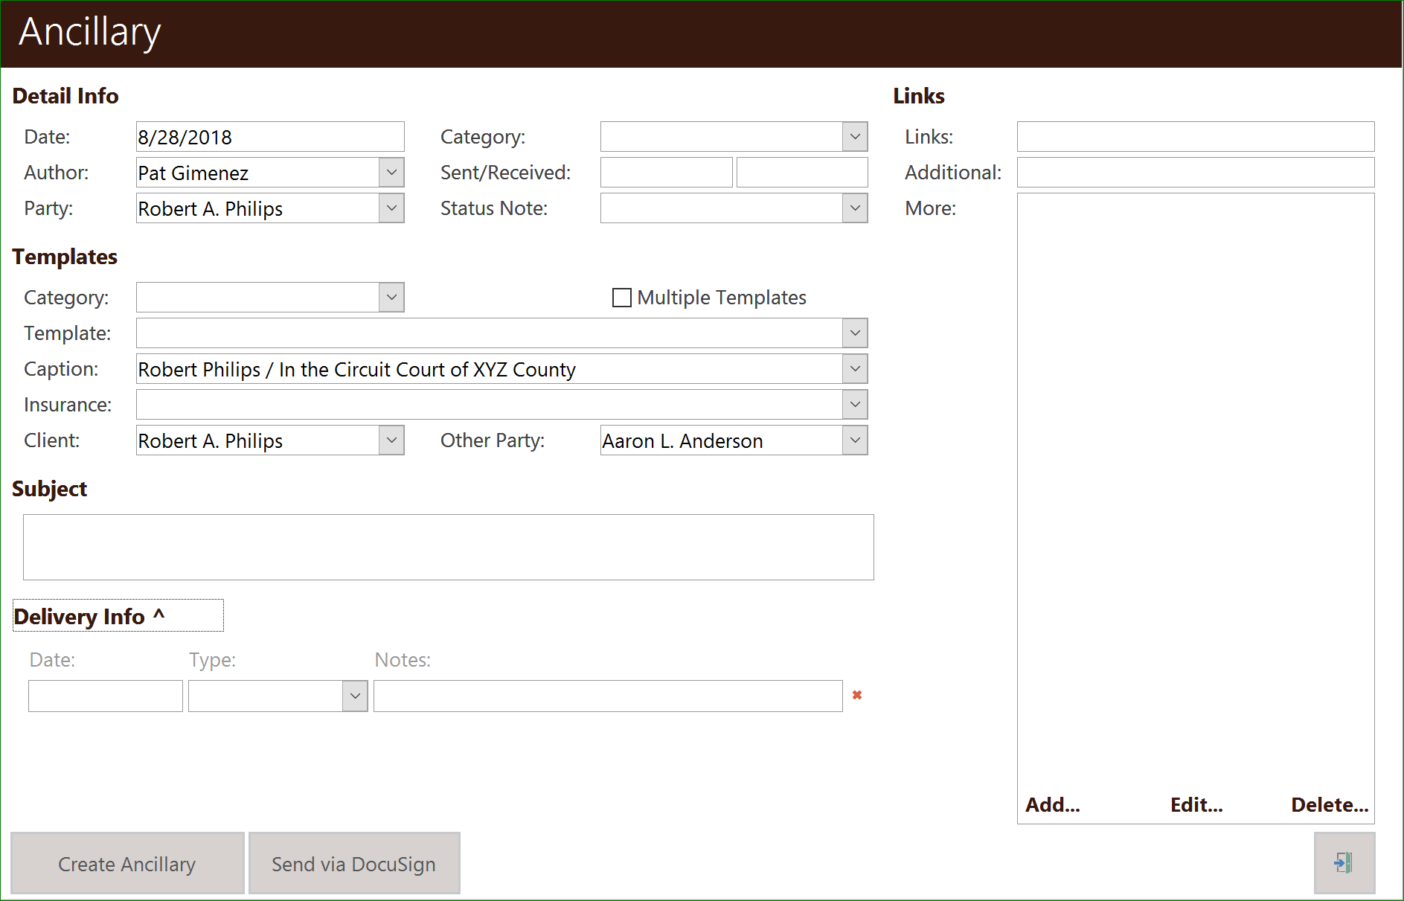
- Defaults in the detail windows  - Date (defaults to today)  - Author (pulls from User Defaults)  - Party (always the first client party name)  - Caption  - Client  - Other Party | - Options  - Template Category  - Template  - Insurance  - Subject  - Document Category
- Links
  - Link
  - Additional
  - More
- Extra Info/Delivery Info

Correspondence
This tab is used to create and track correspondence in a case. Create, save, fax, print, docket, task, calendar, e-mail, and all correspondence activity, and print envelopes
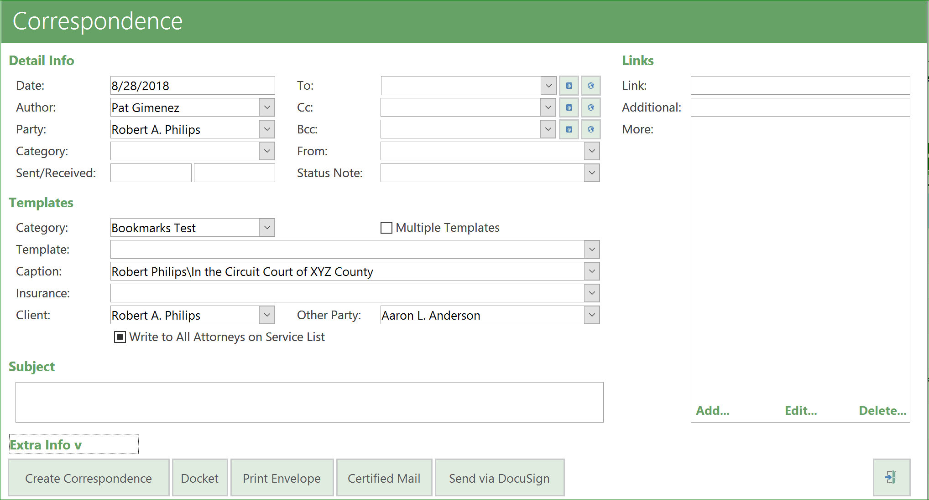
- Defaults in the detail windows  - Date (defaults to today)  - Author (pulls from User Defaults)  - Party (always the first client party name)  - Caption  - Client  - Other Party | - Options  - Template Category  - Template  - Insurance  - Subject  - Document Category
- Links
  - Link
  - Additional
  - More
- Extra Info/Delivery Info

- Choosing one contact or several
  - Add a Contact
  - Global
    - Choose by Contact Type
  - To/CC/BCC
    - If the template doesn’t have a bookmark it won’t fill in the choice

- Properly editing and closing documents
  - When you merge a document, TrialWorks automatically saves that document; however, once you make changes WORD prompts you to save
  - Complete all prompts before closing detail window or document doesn’t save
- Write to All Attorneys on the Service List
  - Pulls from Other Parties
- Multiple Templates
- Detail Button Bar
  - Docket
  - Envelopes
    - Using Stamps.com
  - Certified Mail
    - Walz Forms
  - DocuSign
    - Required additional bookmarks

Medical Tab
Create medical records requests and summaries including diagnosis and treatment, organize medical records for timelines
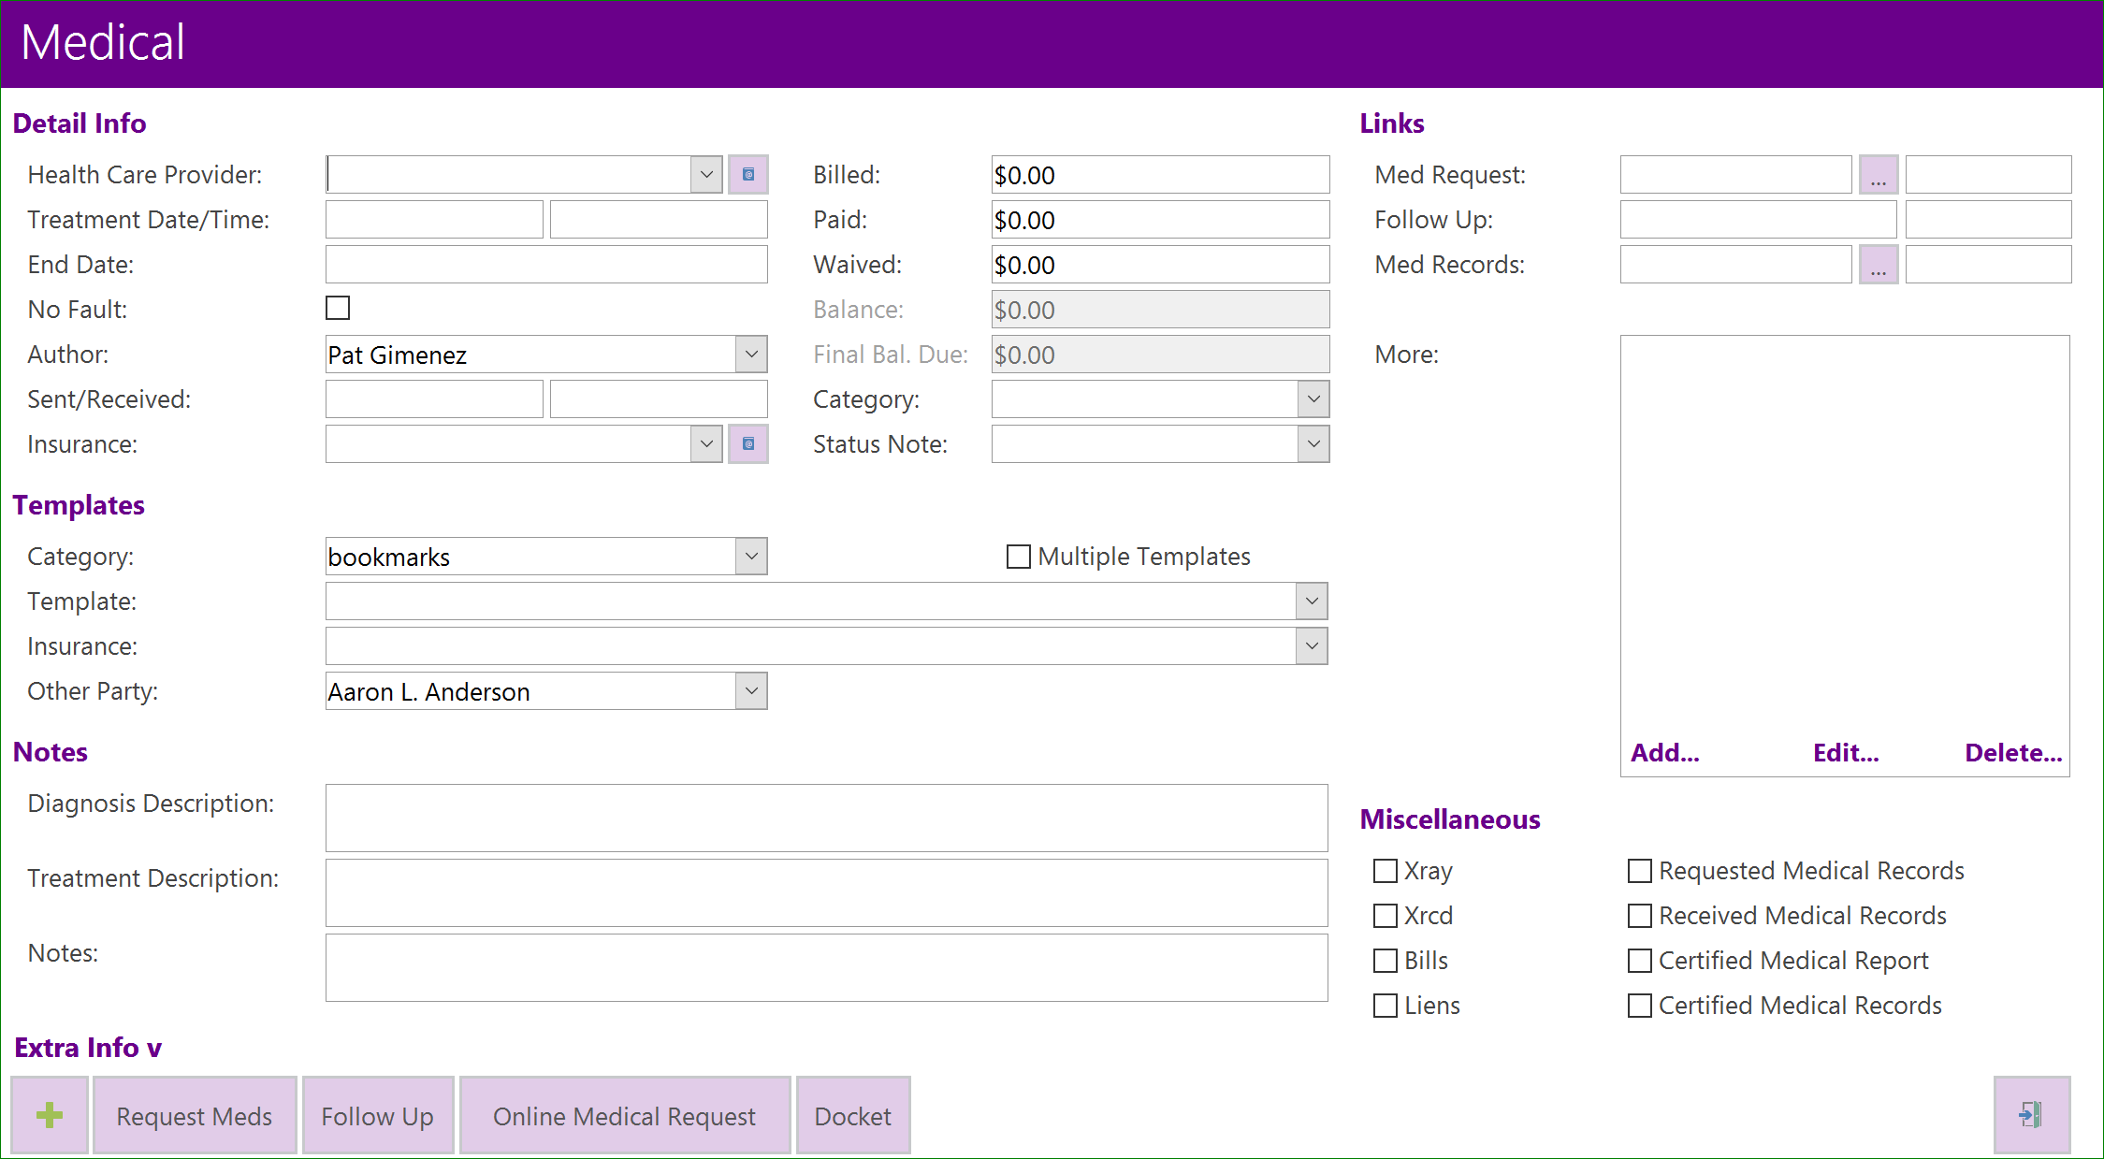
- Defaults in the detail windows  - Date (defaults to today)  - Author (pulls from User Defaults)  - Party (always the first client party name)  - Caption  - Client  - Other Party | - Options  - Template Category  - Template  - Insurance  - Subject  - Document Category
- Links
  - How dates appear next to fields:
    - Link
    - Additional
    - More
- Extra Info/Delivery Info
- Required fields for Requests
  - Health Care Provider Drop-down
    - Contacts Types
  - Treatment Date/Time
  - End Date
  - Author
  - Insurance

- Creating a Request for Medical Records
  - Meds for:
  - Health Care Provider dropdown
- Dates of treatment
  - Start and End Dates

- Once Records are Received
  - Upload records/bills
  - Link to Request
  - Enter financial amounts
    - Amount Billed, Amount Paid (multiple payments), Amount Waived
  - Diagnosis and Treatment
  - Medical Liens
    - If there is a lien for this amount, select “lien” in the Detail window. Details are sent to the Insurance/liens tab and show on Negotiations

- Total Medicals

- Follow Up
  - Select the provider you have requested records from previously and chose template category and template and select “follow up.”

- Medical Reports
Special damages can include medical bills, repairs and replacement of property, loss of wages, and other damages which are not speculative or subjective. They are distinguished from general damages, in which there is no evidence of a specific dollar figure.
  - Include Breakdown
  - Outstanding Medical Requests- Lists date requested along with doctor’s phone number

